**A Data driven generalized approach for DDoS Detection using LSTM Algorithm**

|  |  |
| --- | --- |
| **Ramyaa.M**  Department of CSE  Vel Tech Multi Tech Dr. Rangarajan Dr. Sakunthala  EngineeringCollege,Avadi.  [ramyaamaheshwaran@gmail.com](mailto:ramyaamaheshwaran@gmail.com) | **Monika.M**  Department of CSE  Vel Tech Multi Tech Dr. Rangarajan Dr. Sakunthala  Engineering College,Avadi.  [monikamurugavel17@gmail.com](mailto:monikamurugavel17@gmail.com) |
| **Nivetha.D**  Department of CSE  Vel Tech Multi Tech Dr. Rangarajan Dr. Sakunthala  Engineering College,Ava[di.](mailto:nivedilip2072@gmail.com)  [nivedilip2072@gmail.com](mailto:nivedilip2072@gmail.com) | **Renuka.R**  Department of CSE  Vel Tech Multi Tech Dr. Rangarajan Dr. Sakunthala  Engineering College,Avadi.  [renuka17112001@gmail.com](mailto:renuka17112001@gmail.com) |
| **Vaitheeshwari.D.M.E.(CSE)**  Department of CSE  Vel Tech Multi Tech Dr. Rangarajan Dr. Sakunthala  Engineering College,Avadi.  [vaitheeshwari25394@gmail.com](mailto:vaitheeshwari25394@gmail.com) |  |

**Abstract- This project focuses on detecting Distributed Denial of Service (DDoS) attacks, which have become a major threat to the internet. DDoS attacks target a specific machine or network to make it inaccessible or unusable for a certain period of time. The goal is to improve detection of different types of DDoS cyber threats using better algorithms with higher accuracy, while keeping computational costs under control. This paper proposes a novel detection system for DDoS attacks in Software-Defined Networking (SDN) environments, based on Deep Learning (DL) techniques, particularly the Long Short-Term Memory (LSTM) algorithm. The proposed model is evaluated using the CIC DDoS dataset, which addresses the gaps in existing contemporary datasets.**

***KEYWORDS:* Jupyter Notebook*,* Flask, Python**.

1. **INTRODUCTION**

Software-Defined Networking (SDN) is a brand new era that allows control and programmability of the community system. SDN makes the community extra dependable with the aid of using centralizing it via isolating the manage aircraft from the records aircraft. However the rising paradigm is subjected to many protection vulnerabilities and new faults that may be utilized by attackers to create unique varieties of malicious attacks. Further the not unusual place threats and assaults that can take advantage of the classical community infrastructure also can exist withinside the SDN environment. Moreover those assaults can effect the complete SDN device that consists of multi-gadgets from exceptional carriers in contrast to withinside the conventional community where In well known an assault particularly crashes part of the community gadgets from a unmarried seller most effective with out affecting the complete community. There are many assault vectors that may take advantage of the SDN network .As the range and complexity of cybersecurity assaults boom at a extremely good tempo on a daily basis defenders are in need to find more effective protection measures that rely on machine intelligence. To this account a recent trend in information security is the adoption of solutions based on Artificial Neural Networks (ANNs) to analyse network traffic and the behaviour of software running on computers to identify possible compromised systems or unauthorized access attempts. Compared to conventional signature primarily based totally and anomaly-based approaches ANN based threat detection methods are more resilient to variations on attack patterns and are not constrained by the requirement to define thresholds for attack detection. However training and updating an ANN model for effective threat detection is a non-trivial task especially when dealing with zero-day vulnerabilities and attack vectors due to the complexity and variability of emerging attacks and the lack of data with relevant and up-to-date attack profiles. Reflection-primarily based totally DDoS: Are the ones varieties of assaults wherein the identification of the attacker stays hidden with the aid of using utilising valid third-birthday birthday celebration component. The packets are despatched to reflector servers via way of means of attackers with supply IP cope with set to goal sufferer’s IP.

# **Literature Survey**

**A Flexible SDN-Based Architecture for Identifying and Mitigating Low-Rate DDoS Attacks Using Machine Learning [1]:**

While there were great research of denial of service (DoS) assaults and DDoS assault mitigation, such assaults stay hard to mitigate. For example, Low-Rate DDoS (LR-DDoS) assaults are acknowledged to be hard to detect, especially in a software-described network (SDN).Hence, on this paper we gift a bendy modular structure that permits the identity and mitigation of LR-DDoS assaults in SDN settings. Specifically, we teach the intrusion detection system (IDS) in our structure the usage of six device learning (ML) models (i.e) J48, Random Tree, REP Tree, Random Forest, Multi-Layer Perceptron (MLP), and Support Vector Machines(SVM)) and examine their overall performance the usage of the Canadian Institute of Cybersecurity (CIC) DoS dataset. The findings from the assessment reveal that our technique achieves a detection fee of 95%, in spite of the problem in detecting LR-DoS attacks. We additionally observation that during our deployment, we use the open community running system (ONOS) controller walking on Mini net digital system so as for our simulated surroundings to be as near actual global manufacturing networks as possible. In our checking out topology, the intrusion prevention detection machine mitigates all assaults formerly detected with the aid of using the IDS machine. This demonstrates the application of our structure in figuring out and mitigating LR-DDoS attacks.

**Co-chain-SC: An Intra- and Inter-Domain DDoS Mitigation Scheme Based on Blockchain Using SDN and Smart Contract [2]:**

With the exponential boom withinside the range of insecure devices, the effect of Distributed Denial-of-Service (DDoS) assaults is developing rapidly. Existing DDoS mitigation schemes are going through limitations because of low flexibility, loss of resources, and excessive cost.The new rising technologies, which includes blockchain, introduce new possibilities for low-cost, green and bendy DDoS assaults mitigation throughout a couple of domains.In this paper, we suggest a blockchain-primarily based totally approach, referred to as Co-chain-SC, which mixes degrees of mitigation, intra-area and inter-area DDoS mitigation. For intra-domain, we advise an powerful DDoS mitigation approach withinside the context of software program described networks(SDN); it consists of three schemes: (1) Intra Entropy-based scheme (I-ES) to measure, using Flow, the randomness Of statistics in the domain; (2) Intra Bayes-primarily based totally scheme (I-BS) to classify, primarily based totally on entropy values, illegitimate And (3) Intra-region Mitigation (I-DM) scheme to efficaciously mitigate illegitimate flows withinside the region. For inter-domain, we propose a collaborative DDoS mitigation scheme based on blockchain; it uses the concept of smart contracts (i.e., Ethereum smart contracts) to facilitate the collaboration among SDN-based domains (i.e., Autonomous System: AS) to mitigate DDoS attacks. For this aim, we layout a singular and steady scheme that lets in multiple SDN-primarily based totally domain names to soundly collaborate and switch assault statistics in a decentralized manner.

**Hybrid DDoS Detection Framework Using Matching Pursuit Algorithm [3]:**

Although a large amount of studies has been carried out on DDoS attacks, it nevertheless poses a excessive hazard to many corporations and net provider providers. DDoS assaults typically generate a excessive quantity of community traffic. However, the aid depletion DDoS assaults can deny the goal service, even though it generates lots much less site visitors than valid site visitors. We endorse a singular DDoS detection framework the use of the Matching Pursuit set of rules to locate useful resource depletion kind DDoS attacks. We use a couple of traits of community visitors concurrently with a view to hit upon low-density DDoS assaults efficiently. The proposed technique makes use of the dictionary made out of the parameters of the community site visitors the use of the K-SVD algorithm .Dictionary era the usage of community site visitors, gives valid and assault site visitors models, and provides adaptability of the proposed technique to community site visitors. We additionally enforce DDoS detection processes that use Matching Pursuit and Wavelet strategies and examine them the usage of special statistics sets. Additionally, we provide a hybrid DDoS detection framework that mixes those tactics with a decision-making mechanism the use of an synthetic neural network. We examine the.

**DDoS Attack Detection Method Based on Improved KNN With the Degree of DDoS Attack in Software-Defined Networks [4]:**

The Distributed Denial of Service(DDoS)assault has severely impaired community availability for many years and nonetheless there may be no powerful protection mechanism towards it. However, the emerging Software Defined Networking (SDN) provides a new way to reconsider the defense against DDoS attacks. In this paper, we endorse strategies to locate the DDoS assault in SDN. One approach adopts the diploma of DDoS assault to discover the DDoS assault. The different technique makes use of the advanced K-Nearest Neighbours (KNN) set of rules primarily based totally on Machine Learning (ML) to find out the DDoS attack. The outcomes of the theoretical evaluation and the experimental outcomes on datasets show that our proposed methods can better detect the DDoS attack compared with other methods. The DDoS attack is currently the most serious threat to net- work security in the SDN network. The detection of the DDoS attack is critical to the defence against the DDoS attack. The current DDoS assault detection techniques nonetheless have low accuracy of identity and they may be at risk of different factors. To address the above problems, we have completed the following achievements: Firstly, our proposed four features (i. e., ow length, ow duration, ow size, and ow ratio) are analzsed when the SDN controller is attacked by the DDoS attack. Secondly, for the rst time, a new concept called the degree of attack is proposed and presented to detect the DDoS attack. Based in this concept, a detection set of rules referred to as DDADA set of rules is proposed. In addition, on the way to in addition enhance the detection efficiency, some other detection set of rules known as DDAML set of rules is brought to perceive the DDoS attack. The experimental results show that our proposed algorithms can identify the DDoS attack

**Identifying Application-Layer DDoS Attacks Based on Request Rhythm Matrices [5]:**

Application-layer allotted denial of service (AL-DDoS) assaults have become crucial threats to web sites due to the fact the stealth of AL-DDoS assaults makes many intrusion prevention structures ineffective. To locate AL-DDoS assaults aimed toward websites, we recommend a unique statistical version referred to as the RM (rhythm matrix). Although the original features from the network layer are adopted, the access trajectory, including asked gadgets and corresponding dwell-time values, may be abstracted and gathered into an RM. With an RM, we are able to nearly lossless compress complicated capabilities right into a easy shape and symbolize the consumer get admission to behaviour. We hit upon AL-DDoS assaults consistent with the growth of the abnormality diploma withinside the RM and similarly pick out malicious hosts primarily based totally on change-price outliers. In the experiments, we simulate 3 modes of AL-DDoS assaults with the ultra-modern famous DDoS assault tools: LOIC and HOIC. The results show that our method can detect these simulated attacks and identify the malicious hosts accurately and efficiently. For an AL-DDoS detection method, the cap potential to differentiate flash crowds is indispensable. We additionally exhibit the extraordinary overall performance of our technique in distinguishing flash crowds from AL-DDoS assaults with reconstructed public datasets

# **III. Proposed System Methodology**

**PROPOSED SYSTEM ARCHITECTURE**

We leverage and propose a deep learning approach based on LSTM for detection of DDoS attacks on the SDN. We combine LSTM-CNN with soft max model at the output layer to classify the network traffic into malicious or normal. The trained model behaviour is directly controlled by the values of the hyper-parameters where selecting the best values plays a key role in the success of neural network architecture. However selecting the best values of hyperparameters is still dependent on the best practice or human knowledge. We conducted various experiments to select the optimal values of experiment hyperparameters. The soft max layer takes the decoder output and classifies the input data into normal or attack traffic. We used categorical-cross-entropy as loss function with Adam optimizer and ReLU function for activation in all different layers. We evaluate our model using the new released dataset CIC DDoS which contain a complete sort of DDoS assaults and addresses the gaps of the prevailing cutting-edge datasets. We benchmark numerous brand new ML fashions which might be widely recognized for detection of DDoS attacks and we evaluate our proposed model in terms of precision recall F-score and accuracy. Our proposed approach has the great performance.

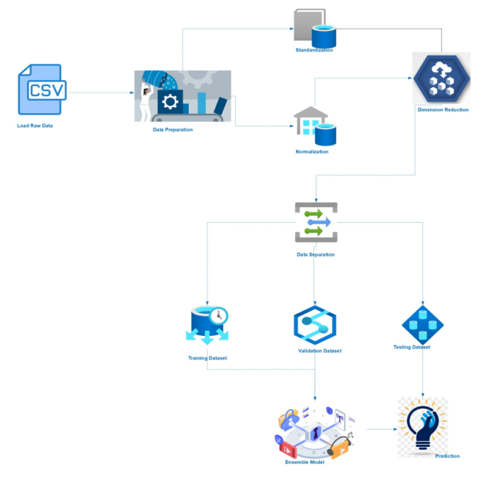

**Fig. 1. Technical Architecture**

The proposed detection approach can be implemented as a standalone rule-based detection tool that considers the digital artifacts of the system where it is being operated in order to detect ongoing cyber-attacks. In addition, Fronesis can be integrated into digital forensics tools to support investigations of cyber-attacks. In this case, Fronesis will consider the digital artifacts of a system to identify the presence of a cyber-attack, its traces as well as the utilized MITRE ATT&CK techniques, MITRE ATT&CK tactics, and CKC phases. Our destiny studies attempt will goal at optimizing Fronesis computational performances as a way to lessen the time had to stumble on an ongoing cyber-attack. Big data technologies, such as Hadoop big data clusters, may be experimented with in this optimization. Our future effort is also focused on the evaluation of Fronesis against cyber-attacks created with the utilization of MITRE Caldera utilization of machine learning (ML) algorithms should be investigated. For instance, Fronesis ontology can be used to dene similarity measures for machine learning models that will be used in identifying similarities

**I. HARDWARE REQUIREMENT**

* Operating System
* Processor
* Memory

## **A. Operating System**

An running machine (OS) is machine software program that manages pc hardware, software program resources, and presents not unusual place offerings for pc programs. Time-sharing running structures agenda responsibilities for green use of the machine and might also consist of accounting software program for fee allocation of processor time, mass storage, printing, and different resources. Hardware capabilities along with enter and output and reminiscence allocation, the working gadget acts as an middleman among packages and the pc hardware ,although the utility code is generally performed immediately through the hardware and often makes machine calls to an OS feature or is interrupted through it. Operating structures are determined on many gadgets that comprise a computer – from cell telephones and online game consoles to net servers and supercomputers.

***B. Processor***

A processor plays arithmetical, logical, input/output (I/O) and different simple commands which might be handed from an running system (OS).Most different methods are depending on the operations of a processor .The phrases processor, relevant processing unit (CPU) and microprocessor are normally related as synonyms. Most human beings use the word “processor” interchangeably with the term “CPU” nowadays, it's far technically now no longer accurate because the CPU is simply one of the processors inner a non-public computer (PC). The Graphics Processing Unit (GPU) is every other processor, or even a few tough drives are processor, and even some hard drives are technically run a computer ,input and output.

**C. Memory**

Memory is the digital maintaining location for the commands and information a pc wishes to attain quickly .It's in which data is saved for fast use. Memory is one of the fundamental capabilities of a laptop, due to the fact with out it, a laptop could now no longer be capable of feature properly. Memory is likewise utilized by a computer's working system, hardware and software.

# **II. software requirements**

* Jupyter Notebook
* Python
* Python flask

## **A. JupyterNotebook**

Jupyter Notebook(previously IPython Notebooks) is a web-primarily based totally interactive computational surroundings for growing Jupyter pocket book documents. The "notebook" time period can colloquially make connection with many exceptional entities, in particular the Jupyter net application, Jupyter Python net server, or Jupyter record layout relying on context. A Jupyter Notebook file is a JSON file, following a versioned schema, containing an ordered listing of input/output Cells that could include code, text (the use of Markdown), mathematics, plots and wealthy media, generally finishing with the ".ipynb" extension. A Jupyter Notebook may be transformed to some of open general output formats(HTML, presentation slides, LaTeX, PDF, Re-Structured Text, Markdown, Python) through "Download As" withinside the internet interface, through the nbconvert library or "jupyter nbconvert" command line interface in a shell. To simplify visualisation of Jupyter pocket book files at the web, the nbconvert library is furnished as a carrier via NbViewer which canTake a URL to any publicly to be had pocket book document, convert it to HTML at the fly and show it to the user. Jupyter Notebook can connect to many kernels to allow programming in different languages. three release (October 2014), there are presently forty nine Jupyter-like minded kernels for lots programming languages, such as Python, R, Julia and Haskell.

***B. Python***

Python is a runtime environment object-oriented high-level computer program with dynamic semantics. Since there is no compilation phase, the modify cycle is extremely fast. A source level breakpoint allows users to inspect local and global variables, run arbitrary expressions, set breakpoints, step through the code one line at a time, and so on. Python provides modules and packages, which assists with programming modularity and code reuse.

**C*. Python Flask***

Python Flask is used to develop applications using python. Flask is mainly used to render and integrate the chatbot application in the browser by providing API. By running the python application, the suitable server domain link is obtained and run in the browser

# **IV. Result and analysis**

Network virtualization results in new threats and new exploitable assaults that those already current withinside the conventional network. The DDoS assault magnificence is taken into consideration one of the maximum competitive assault kinds in latest years inflicting a important effect at the complete community system. The advent of ubiquitous network-based technologies has increased the associated vulnerabilities. The need for effective network protection tools have never been greater .In this paper we advise an AI-primarily based totally IDS this is able to distinguishing among everyday and DDoS traffic .In this paper we proposed a new model that is based on DL for the detection of DDoS attacks against SDN network. We used the brand new launched CIC DDoS dataset for education and assessment of our proposed model. The dataset carries complete and maximum current DDoS kinds of attacks. The evaluation of our model showed that gives the highest evaluation metrics in terms of recall precision F-score and accuracy compared to the existing well known classical ML & DL techniques.

**ADVANTAGES**

• Ability to procedure huge quantity of statistics quick so one can come across attacks.

• Better decision-making as to the training time. Efficiently improve time efficiency involves the computation time and communication time

• Eliminating the huge workload of traditional methods Proving High Robustness and imperceptibility

# **RESULT OF TRAINING MODEL**

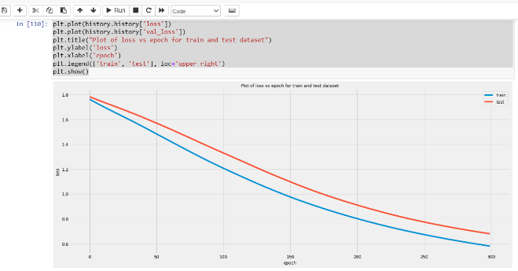

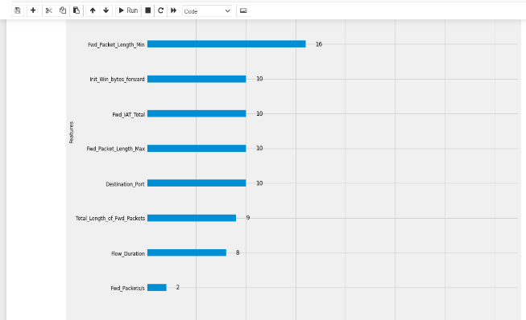

**V. Conclusion**

Network virtualization ends in new threats and new exploitable assaults that those already present withinside the conventional network. The DDoS assault magnificence is taken into consideration one of the maximum competitive assault sorts in current years inflicting a important effect at the complete community system. The advent of ubiquitous network-based technologies has increased the associated vulnerabilities. The need for effective network protection tools have never been greater. In this paper we suggest an AI-primarily based totally IDS this is able to distinguishing among everyday and DDoS traffic. In this paper we proposed a new model that is based on DL for the detection of DDoS attacks against SDN network. We used the brand new launched CIC DDoS dataset for education and assessment of our proposed model. The dataset consists of complete and maximum current DDoS varieties of attacks. The evaluation of our model showed that gives the highest evaluation metrics in terms of recall precision F-score and accuracy compared to the existing well known classical ML & DL technique.

**VI. Future Enhancements:**

In the destiny we're interested by checking out the overall performance of our proposed version on different datasets. In this contemporary paintings we used a binary category framework to categorise the enter site visitors into regular and malicious types. However it's also important to categorise every man or woman assault sorts separately. We intend to increase our paintings to a multi-magnificence category framework. Furthermore we are able to simulate the SDN community with diverse styles of environments and attack Traffics to create a heterogeneous dataset which can efficiently constitute the present day net traffic.

**VII. References:**

[1] “ A Flexible SDN-Based Architecture for Identifying and Mitigating Low-Rate DDoS Attacks Using Machine Learning ” by Jesús Arturo Pérez-Díaz; Ismael Amezcua Valdovinos; Kim-Kwang Raymond Choo; Dakai Zhu,Published in IEEE in 2015

[2] “ Co-chain-SC: An Intra- and Inter-Domain DDoS Mitigation Scheme Based on Blockchain Using SDN and Smart Contract ” by Zakaria Abou El Houda; Abdelhakim Senhaji Hafid; Lyes Khoukhi, Published in IEEE in 2019.

[3] “ Hybrid DDoS Detection Framework Using Matching Pursuit Algorithm ” by Derya Erhan; Emın Anarim , Published in IEEE in 2020.

[4] “ DDoS Attack Detection Method Based on Improved KNN With the Degree of DDoS Attack in Software-Defined Networks ” by Shi Dong; Mudar Sarem, Published in IEEE in 2019.

[5] “ Identifying Application-Layer DDoS Attacks Based on Request Rhythm Matrices ” by Huan Lin; Shoufeng Cao; Jiayan Wu; Zhenzhong Cao; Fengyu Wang, Published in IEEE in 2020.